While in Office365 mail (Outlook) click on the setting icon.
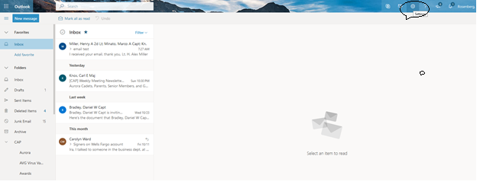
Click on “view all outlook settings”
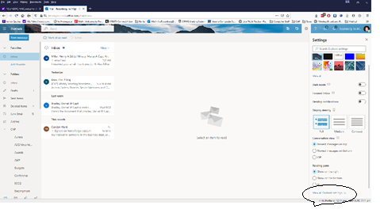
Click on “forwarding”
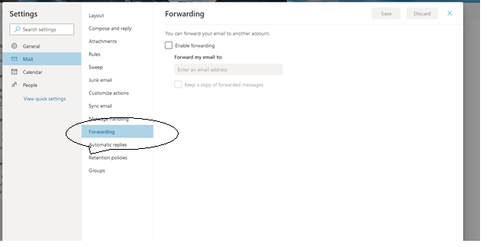
Click on “Enable forwarding”
Enter the email address that you want these messages to go to.

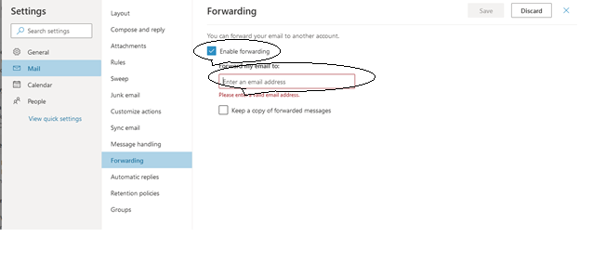
Click on “Save”

